ADV 3008 M/W
Fall 2010

Team Clean:
Aaron Greenfield
Kiffanie Shoults
Jared Liebmen
Bryan Scott

ZEST Team 11



Table of Contents
Chapter 1: Business Description pg 3
Situation Analysis pg 4
SWOT Analysis pg 4
Chapter 2: Brand Equity Inventory pg 5
Brand Heritage pg 6
Brand Representatives pg 6
Brand Identifiers pg 6
Brand Domain pg 6
Brand Essence pg 6
Key Strategy Questions pg 7
Chapter 3: Brand Personality Statement pg 8
Chapter 4: Competitive Map pg 9
Chapter 5: Target Consumer Description pg 10
Chapter 6: Positioning Statement pg 10
Additions Selling Resources pg 11
Chapter 7: Strategic Message Map pg 12
Chapter 8: Creative Work Plan pg 13 -14
Chapter 9: Brand Promotions and Rationale pg 15
Chapter 10: Billboard Advertisements pg16-18
Business Description:
Images:
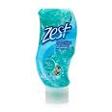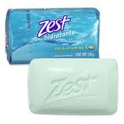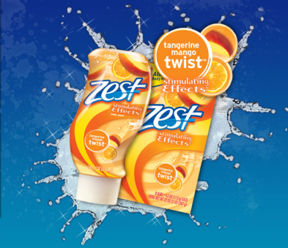
In today’s market of beauty and grooming, it is becoming increasingly important to have an edge over competitors. Marketing a product that is appealing to consumers in a way that other companies have not already done is vital to the life of a product. It is essential to capture the consumer early and prove to them that your product is effective and is able to meet and exceed their needs and expectations far more than a competitor’s brands can. By establishing a history with consumers, it becomes easier to maintain consumer relationships while building your brand equity. Beauty and Grooming is an area with little room for error. With new and innovative ideas making headway in the market every day, it is difficult for companies to establish their own place in the market and maintain their status of being a successful competitor for years to come.
Zest Competes in the beauty and grooming market, with big names such as Old Spice, Axe, Olay and many more. Zest is in an ever-growing category. With new brands emerging frequently, it is important to stay in touch with the needs of the consumer. Brands such as Old Spice and Axe are coming out with new body wash products with scents that are not only refreshing, but work to block odors as well. These new product lines appeal to multiple groups of men, from those who are more of the metro sexual type to those who consider themselves more rugged, and everything in between. Gaining a competitive edge against companies such as these that thrive on their wide-ranging appeal is crucial to the ongoing success of a brand such as Zest.
Due to the current state of the economy, many consumers have turned to less expensive brands to meet their needs. In the case of Zest, it may be a perfect time to resurface and reinvent the brand to revive all its forgotten glory. Zest’s popularity over the past few years has declined. It is our group’s assumption that, unlike many other products, it is not the economy that is affecting Zest’s sales, but rather their lack of advertising. Zest, compared to other comparable products, is rather inexpensive, thus being very appealing to consumers in these economic times. Through rebranding and reinventing the image that Zest portrays, there is hope to reposition it as a leading competitor in the beauty and grooming market.
Though price is important, it is usually not the ultimate deciding factor for consumers when choosing a personal hygiene product. Quality and reliability are also factors that are of utmost importance to the consumer. Simply because the product is cheaper, does not mean it is going to be a suitable substitute for what the consumer is accustomed. Zest competes with major companies such as dove, Axe, and Old Spice for soaps and body washes. Each company has attributes that appeal to various consumers. Axe and Old Spice are advertised as deodorizing soaps, while others, such as Dove, are used with the intent of giving its users a fresh scent while also having a moisturizing effect on user’s skin. Zest is a soap that, since its beginning, has simply been advertised to clean while leaving very little residue on both skin and on bathtub surfaces.

Zest Situation Analysis:
Zest has always been a well known brand name in today’s market. It is considered being to be a good clean soap that leaves no residue behind. The soap and body cleansing market is constantly changing which gives Zest the opportunity to make its way to the top of the market.
Challenges:
- Zest had not been marketed with a lot of publicity in recent years
- It is hard to find Zest on store shelves
- There are many new wash products that have taken off in the market
- Changing the perception of Zest

Opportunities:
- To become the leading brand of wash products
- Change the target market to a younger generation
- Cost/Benefit of switching the target market, (needs to include production of body washes)

SWOT Analysis:

Strengths:  - Was a very well known brand  - Logo and brand recognized internationally  - Multi-million dollar budget available to continually promote the brand? | Weakness:  - Zest has been out of the “spotlight” for a while.  - There are many well know body heigenic products.  - The average person does not necessarily know that Zest carries what was a well-known brand at one point
Opportunities:  - Overcoming the “slump” they are in  - Regain respect and credibility  - To position themselves as one of the top soaps if not the top soap. | Threats:  - Well established companies that pose a challenge to surpass  - Sluggish economy  - Many older people use Zest, not the younger generation
Brand Equity Inventory:

Within the next few pages is a description of the brand’s past, present and future. There are also some pictures of the various products the brand carries in today’s market.

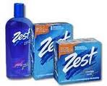
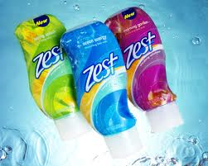
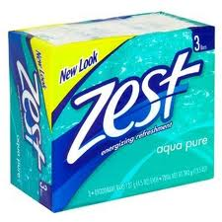
Brand Heritage:
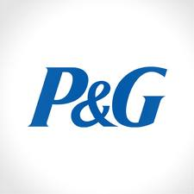
Marketed under Proctor and Gamble, Zest introduced its soap products in 1958 with the claim that it was not an ordinary soap because it did not leave a sticky film like many other soap brands at that time did. “For the first time in your life, feel really clean” was used as the slogan to launch the Zest brand. Throughout the 1980’s and early 1990’s the brand saw a rise in sales, however, in recent years sales have declined due to competition.
Brand Representatives:
Zest is best recognized for its bar soap. It green color and rectangular shape are original characteristics of Zest and have become simple associations of the brand.
Brand Identifiers:
Zest products are best recognized by “Zest” printed in rounded, bold, white letters outlined in a royal blue hue. This design along with a series of commercial has been used to present a straightforward “Zestfully Clean” idea to consumers. Along with the Zest logo, P&G place their signature star and moon design on the packaging to give the consumer assurance that it is, indeed, a quality product.
Brand Domain:
Zest competes in the market of beauty and grooming products. In addition to these, shampoos, conditioners, and lotions would be a logical extension of Zest to complete the company’s personal hygiene product line.
Brand Essence:
“Zestfully clean!”

Key Strategy Questions:
Which of the characteristics above must be retained?
Zest must remain a brand that is known for its quality. The name “Zest” also gives the soap a personality characteristic rather than describing the actual product, making it unique and interesting to buyers.

Which should be evolved?
Zest is a brand that is associated with quality. It has become a household name, though it seems to be marketed primarily toward a middle-age to older-age group. Its packaging is a bit dated and should be changed to give a more modern impression. Zest is a name that describes an attitude of liveliness and having an appetite for life, therefore it should be rebranded and targeted toward a younger age group – those who are “on the way up”.

Are there negatives we should strive to eliminate?
Zest bar soap is marketed primarily toward an older age group. Zest is a word associated with those who are of a younger generation, and therefore should be the target market. From its various scents to its packaging design, it seems to be outdated and of substandard quality.

Brand Personality:
If Zest were to embody a public figure, it would be George Clooney. Modestly, Zest has taken his place in the industry. He has become a well recognized and respected product that made his initial mark many years ago, but continues to be a pervasive and lively figure. His true fans remain loyal as he is known for delivering quality each time he is expected to perform. Through his dynamic attitude, he continues to entice many new fans from a variety of generations. He is an iconic figure and a household name.
His image is clean cut, simplicity with a hint of pizzazz. He is not known to parade around in pricey clothing, but rather, he prefers casual, moderately priced pieces in his wardrobe. Think Ralph Lauren, or maybe even Brooks Brothers.
He is ageless, and because of that that, a bit of peculiarity can be found. Everything from Bonnie and Clyde to The Longest Yard can be unearthed in Zest’s collection of DVDs. He is humorous with a bit of a playful side. His favorite show is Jon Stewart because he is so great at being funny without losing his intellect.
If a YouTube biography were made, Zest would tell of his beginnings and how he has stood firm to his original product image throughout the years, unwavering in his pursuit to maintain an image of ardent quality.



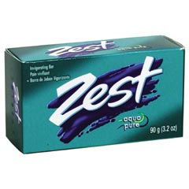
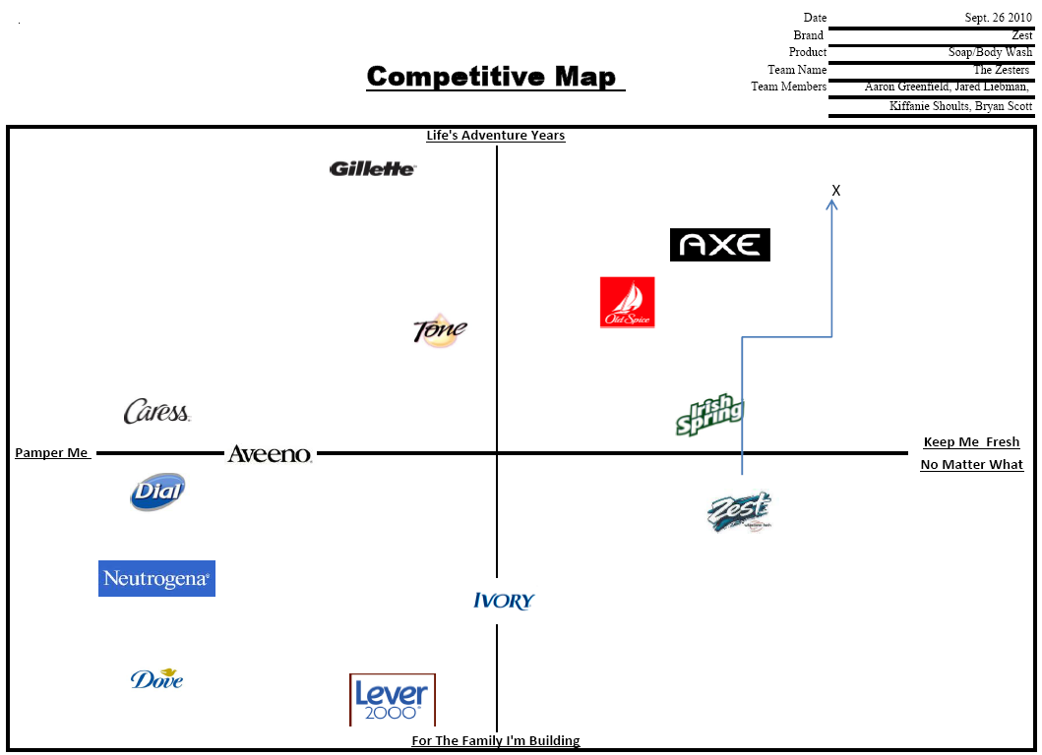

Target Consumer:
Zest is targeting the young American with an appetite for life. Zest has been a brand based on old fashion values and the ability to give consumers a product that is reliable to them in all stages of life, whether they are men or women. Zest is currently attempting to rejuvenate their brand with a new line of body washes that will appeal to a more specific crowd of young men between the ages of 20 and 30 who’s ambitions for life are matched by Zest’s values. To the young American man with an appetite for independence and success, Zest is the brand as superior as you strive to be.
People today are looking for something exciting, affordable, and reliable; Zest has the ability to deliver those qualities through their new line of body wash. Zest’s body wash will act as the new age of Zest and appeal to youth, while their traditional bar soap will still be offered as well for more traditional users. Zest needs a boost that can show people that it is exciting, and can deliver that zesty clean feeling like no other. Today’s Americans are looking for that edge, which is just what Zest has to offer.
Zest bar soap is a well established product and has been for years , and has always been known for being a true soap, leaving no soap scum marks, in fact Zest helps to clean your tube as well as cleaning your body. Now with its new line of body wash Zest is attempting to reposition their brand to appeal to a younger generation. Zest primary distribution areas are in the United States but Zest also ships outside the country to Canada, France and the United Kingdom.
Zest is a very trusted brand that has found its place in the middle class. Zest does this by creating a well manufactured product that are reasonably priced and appeal to people looking for a dependable brand that is effective. Zest is extending their reach into the younger generation with their new line body wash soaps that are just as effective as their traditional bar soap just with a new twist, as well as scents.
As a bar soap in the past Zest has marketed itself to a wide range of consumers. It has made its name by appealing in large to an older market, although with Zest’s new line of body washes they’re taking a new direction to capture the younger more upbeat and adventurous market of young adults in an attempt to recreate themselves. If Zest can capitalize on successfully attracting new attention to their body wash line they can rebuild a once very popular brand back into stores around the world. By creating a new desire and appetite for Zest by younger people who can continue to use Zest products throughout their life.
Positioning Statement:
To the young American man with an appetite for independence and success, Zest is the brand as superior as you strive to be.
Major Selling Idea:
Set the assurance of being clean with smelling good. No residue left behind.
Media to be used:
- Television
- Newspaper
- Radio
- Internet
- Magazines

Therefore what kind of ads will you create?
Our first ads will appeal to the younger American man. Someone who has a drive for success with failure not being an option.

Advertising Objective: To introduce Zest to a new generation of consumers.
Core Target Profile: Young adults both men and women with a passion for life that what more out of a soap/body was that they cant get anywhere else, Dedicated ambitious sparkling clean people.
THINK NOW
DO NOW
DIFFERENTIATING PROPOSITION
THINK IN FUTURE/
DO IN FUTURE
I enjoy feeling clean.
I don’t like cleaning my bath tub.
I like feeling fresh and clean for the opposite sex.
Zest, a cleaner clean, a fresher start
.
Zest has what I need to push myself first thing in the morning.
I just feel much cleaner when I use it
Zest improves my day.
Zest is Awesome.
SUPPORT

TONE & MANNER
MANDATORIES
Empowering, Fresh, Fun, Bright
Bright colors and Zest logo
Creative Work Plan:
Purpose of the Advertising:
The goal is to recreate the Zest brand to a new generation of users that can revitalize the company into a new era of business. Letting consumers know that Zest is a superior brand that can compete with top end brands such as Old Spice and Axe Body Wash. By addressing Zest’s body ash line we hope to attract young users who are hungry for something that is both reliable and different than the everyday norms. The Consumers must think they are ambitious and forward moving, feel as if they can achieve almost anything given the right tools, or get the mindset that Zest can make a difference in their clean over other similar brands of soap and body wash.
The Advertising is addressed to:
Zest Audience is between the ages of 21 – 30, who are hard working, up and coming individuals who wants something extra in their soap. They feel as if their soap is an extension of themselves, giving them more than they asked for with every use no matter what the situation. Zest targets users in a busy city typesetting, with a fast pace life style that requires a superior need for clean. Their lifestyles range from the individual hard working adult to the new family looking to still feel that consistent clean.
Major Selling Idea:
Zest capitalizes on their Superior clean like no other while leaving the users with not only the feeling of a cleaner clean , but the idea that their lust for life is also embodied in there type of soap or body wash. The idea that Zest can give them a feeling that other products cant leaving them fresh and clean to go out and be ambitious in the world with a feeling of confidence and go forward attitude.
Media to be used:
TV commercials- TV commercials are an effective way to portray messages about a
brand and what it has to offer the consumer. Commercials grab the viewer’s
attention for a short moment in time and are able to influence their opinions
and attitudes of the brand.
Facebook- The target market for Zest is statistically made up of a vast number
of Facebook users. Many eye-catching and effective ads are placed on the side
panels Facebook profiles each day so they are seen by countless users
repeatedly. Facebook adds the extra benefit of providing an interactive link
unlike TV or print ads.
Print- Print advertisement is the most traditional form of advertising. It would
work great for Zest because it can be placed in specific locations that will
best reach the target market.
Ads to be created:
Zest ads will be catch and to the point, letting consumers know we are a upbeat product that does not have time to mess around and bore you with long commercials. The commercials should be between 20 – 30 seconds, with bright colors and attention getting phrases, something fresh and appealing to our target consumers. On the side of print ads Zest will use Magazines such as GQ or the Time, and Newspaper ads in local newspapers around the country. to inform new consumers and old that Zest still has what it take to be a high end product while at the same time letting users know of any new benefits of products Zest has to offer. They would be no longer than column to half a page depending on the type of promotion being done. For Internet we are targeting facebook, creating ads and promotional deals on a facebook page where customers can see all the new ideas Zest is creating as well as have chance to win prizes on promotions and be part of ad campaigns where their input is valued and used.

Brand Promotions and Rationale:
Promotion #1:
- Test the Zest, Facebook challenge

Rationale:
What – Using Facebook to create interactive games to appeal to new consumers and create special offers to entice them to use Zest products such as coupons or promotional sales on new products to be released. This new generation of consumer to Zest products will help establish new brand loyalty towards the company. By collaborating with disaster relief organizations such as, as well as local charities and homeless shelters around the United States, in order to promote good brand image.
Goal – This Promotion will give Zest the opportunity to not just build a brand target but also a chance to give back to the community it provides for, By doing this we are establishing the branding of Zest products within the community.
Why – In turn thus would help to shape Zest’s brand image for the new era of users, providing a sense of social responsibility as well giving them peace of mind when using Zest products.
Promotion #2:
- Billboards / TV

Rationale:
What – Using TV and Billboards to make consumers aware of Zest’s newer products, such as the body wash series. We would use sexy images of both men and women using Zest products, to appeal to users towards Zest’s higher quality clean feeling as well the way it can make you feel after using Zest’s soaps. Attaching slogans like “Don’t Wear Your Soap” as well as “Zest It’s That Good” to entice customers to use our products for the not just their practical application but the way they make them feel as they start their day or even their evening.
Goal – Working with local businesses in the area, we would give out free samples for consumers to try to catch the Zest way of thinking.
Why – We are doing this to create awareness to the consumer that we can be functional and clean while still being fun, ambitious, and sexy.




